4-HTML. Tablas. Entrega práctica 4.1

<!DOCTYPE html>
<html lang="es">

<head>
<title>1.1Tablas</title>
<meta charset="UTF-8">
</head>
<body>
<table border="1">
<tr>
<td>Rodriguez Pablo</td>
<td>1700</td>
</tr>
<tr>
<td>Lopez Ana</td>
<td>1950</td>
</tr>
<tr>
<td>Gomez Luis</td>
<td>1473</td>
</tr>
<tr>
<td>Mendez Carlos</td>
<td>1640</td>
</tr>
</table>
</body>
</html>

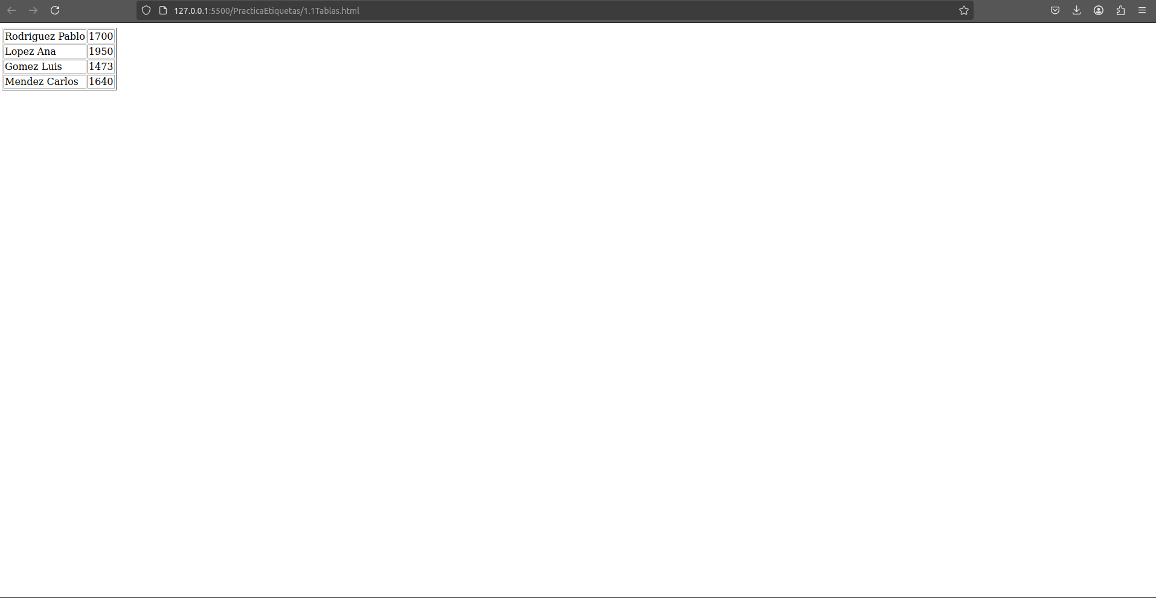

<!DOCTYPE html>
<html lang="es">

<head>
<title>Periódicos</title>
<meta charset="UTF-8">
</head>
<body>
<table border="1">
<tr>
<th rowspan="4">Argentina</th>
</tr>
<tr>
<td>La Nación</td>
<td><a href="https://WWW.lanacion.com.ar">www.lanacion.com.ar</a></td>
</tr>
<tr>
<td>Clarín</td>
<td><a href="https://WWW.clarin.com.ar">www.clarin.com.ar</a></td>
</tr>
<tr>
<td>La voz del interior</td>
<td><a href="https://WWW.lavoz.com.ar">www.lavoz.com.ar</a></td>
</tr>
<tr>
<th rowspan="4">España</th>
</tr>
<tr>
<td>El País digital</td>
<td><a href="https://WWW.elpais.es">www.elpais.es</a></td>
</tr>
<tr>
<td>ABC</td>
<td><a href="https://WWW.abc.es">www.abc.es</a></td>
</tr>
<tr>
<td>El Mundo</td>
<td><a href="https://WWW.elmundo.es">www.elmundo.es</a></td>
</tr>
<tr>
<th rowspan="3">México</th>
</tr>
<tr>
<td>La Jornada</td>
<td><a href="https://WWW.jornada.UNAM.mx">www.jornada.UNAM.mx</a></td>
</tr>
<tr>
<td>El Universal</td>
<td><a href="https://WWW.el-universal.com.mx">www.el-universal.com.mx</a></td>
</tr>
</table>
</body>
</html>

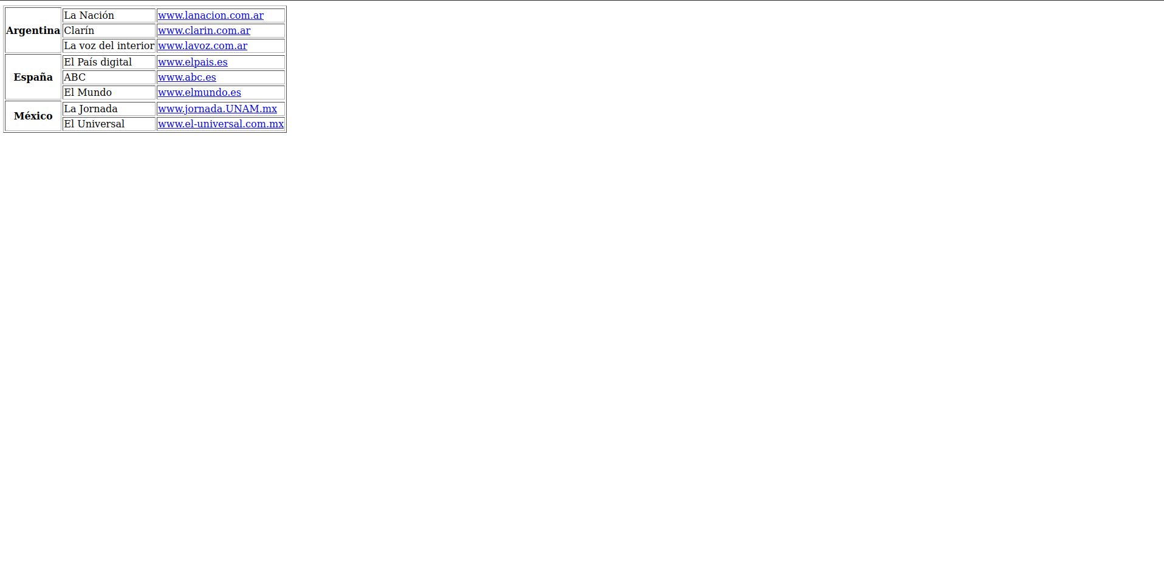

<!DOCTYPE html>
<html lang="es">

<head>
<title>Recursos</title>
<meta charset="UTF-8">
</head>
<body>
<table border="1">
<tr>
<th rowspan="4">Recursos</th>
<th colspan="4">Facturación</th>
</tr>
<tr>
<td>Discos Duros</td>
<td>23000</td>
<td>27200</td>
<td>26000 </td>
</tr>
<tr>
<td>CPU</td>
<td>73000</td>
<td>67300</td>
<td>51000</td>
</tr>
<tr>
<td>Monitores</td>
<td>53000</td>
<td>72000</td>
<td>88000 </td>
</tr>
</table>
</body>
</html>

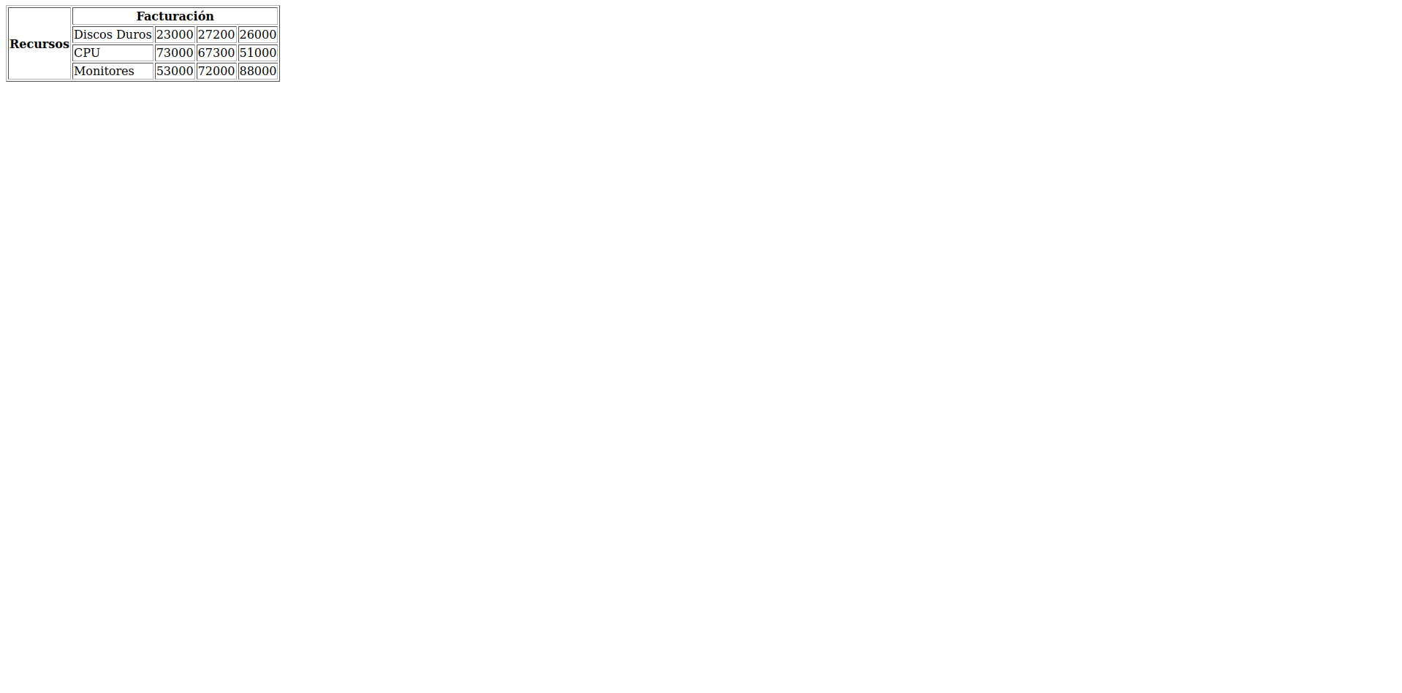

<!DOCTYPE html>
<html lang="es">

<head>
<title>Tabla combinación de fiolas y columnas</title>
<meta charset="UTF-8">
</head>
<body>
<table border="1">
<caption>Tabla con combinación de filas y columnas</caption>
<tr>
<th>celda 1</th>
<th>celda 2</th>
<th>celda 3</th>
<th>celda 4</th>
</tr>
<tr>
<td rowspan="3">celda 5</td>
<td colspan="2">celda 6</td>
<td>celda 7</td>
</tr>
<tr>
<td>celda 8</td>
<td>celda 9</td>
<td rowspan="2">celda 10</td>
</tr>
<tr>
<td colspan="2">celda 11</td>
</tr>
</table>
</body>
</html>

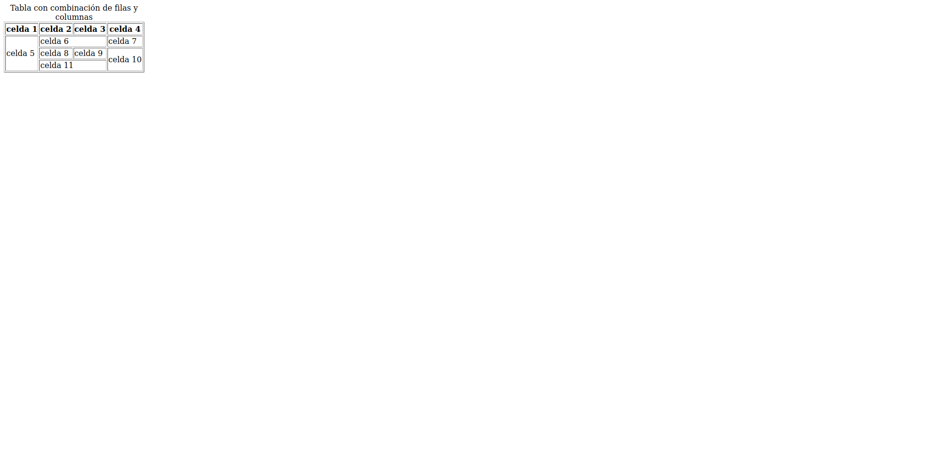

<!DOCTYPE html>
<html>

<head>
<style>
table,th,td {border: 9px solid black;}
th,td {padding: 20px;}
</style>
</head>
<body>
<table>
<tr>
<th>Enero</th>
<th>Febrero</th>
</tr>
<tr>
<td>100</td>
<td>200</td>
</tr>
<tr>
<td>345</td>
<td>800</td>
</tr>
</table>
</body>
</html>

